Lakefront living is typically the first property type that people think of when they begin to consider purchasing a lake home. However is it the best option? There are a few other property types that should be considered as well including lake view and lake access properties.
A lakefront property is one that sits directly on the edge of the lake. Lake view is when your home has a view of the lake but does not sit directly on the edge of the water, and lake access means that your property does not sit on, and might not have a view of the lake, but does have access to the lake either via a dock or a path.
Initial Factors to Consider
How do you know which is best for you? When deciding whether to choose lakefront, lake view or lake access, initially most buyers gravitate toward lakefront because they want to be right on the water. However, after you factor in location and price, lakefront may not be the best option for you.
First you need to figure out which criteria is most important to you. Is it being right on the waterfront, sticking to you budget, or being in your perfect neighborhood? After you decide which characteristic is your top priority, next you need to think about how often you will be visiting the lake and how you see yourself spending time at your lake house.
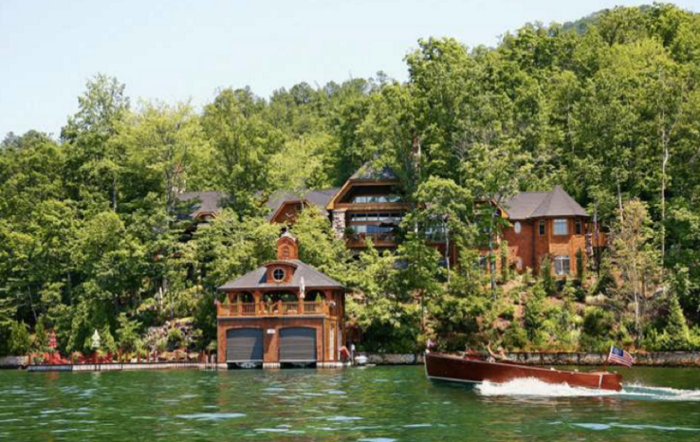
Lakefront home on Lake Burton, GA
Cost
If you are set on a certain lake and have a strict price range, lake view may be the better option. Each lake will have a general price range and they will vary between lakes. If you are open to different lakes, you may find that other lakes allow you to buy a lakefront home within your budget.
A pro of purchasing lakefront property is that it is a scarce resource, and there is only a limited amount per lake. A lakefront property or land will be worth more if you decide to sell it, especially if the area doesn’t have much other property for sale. A pro of purchasing lake view or lake access is that typically these properties do not cost as much since they are not right on the water.
Another factor to be mindful of when purchasing a lakefront property is the cost of upkeep from erosion, dock repairs, and any remodeling needed from being directly on the water. These are costs that you will need to pay the entire time that you own the property. If you owned a lake view property, you would not need to factor in these costs.
Lake view property
Activities
The main activities you see yourself spending the majority of your time should be largely considered when deciding which type of property you will buy. If you love boating, you will want a house with access to a dock. Whether the dock is attached to your property or is a community dock is your personal preference.
If swimming is your favorite activity, a water front property may be best for you. For swimming you will need to consider the depth of the water surrounding your property and if the lake is at full pool year round or not, how rocky the bottom may be, boat traffic, and safety surrounding the area that you will be swimming in.
It is important to be mindful or the area in which your property will be as well. Some houses sit on main channels which can indicate that there will be more boat traffic and others are tucked into quieter coves. Houses in coves tend to be more secluded and have less traffic.
If you are someone who loves a busy lake and enjoys having people around then a main channel, lakefront property may be best for you. On the contrary if you prefer a secluded spot, you may be interested in a property seated in a cove that is lakefront or lake view.
All in All
Whether you prefer a lakefront, lake view, or lake access property is entirely up to you and your unique buying situation. Considering all of your options and knowing which property types are available in your area are just other pieces to the buying process.

